EMELIA PRESS KIT
Production Stills - Ready for print
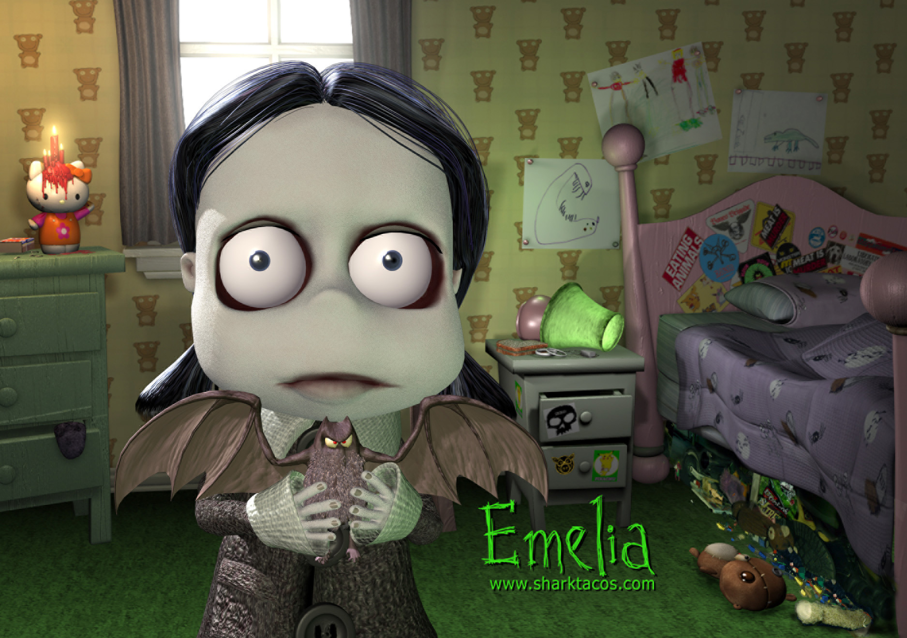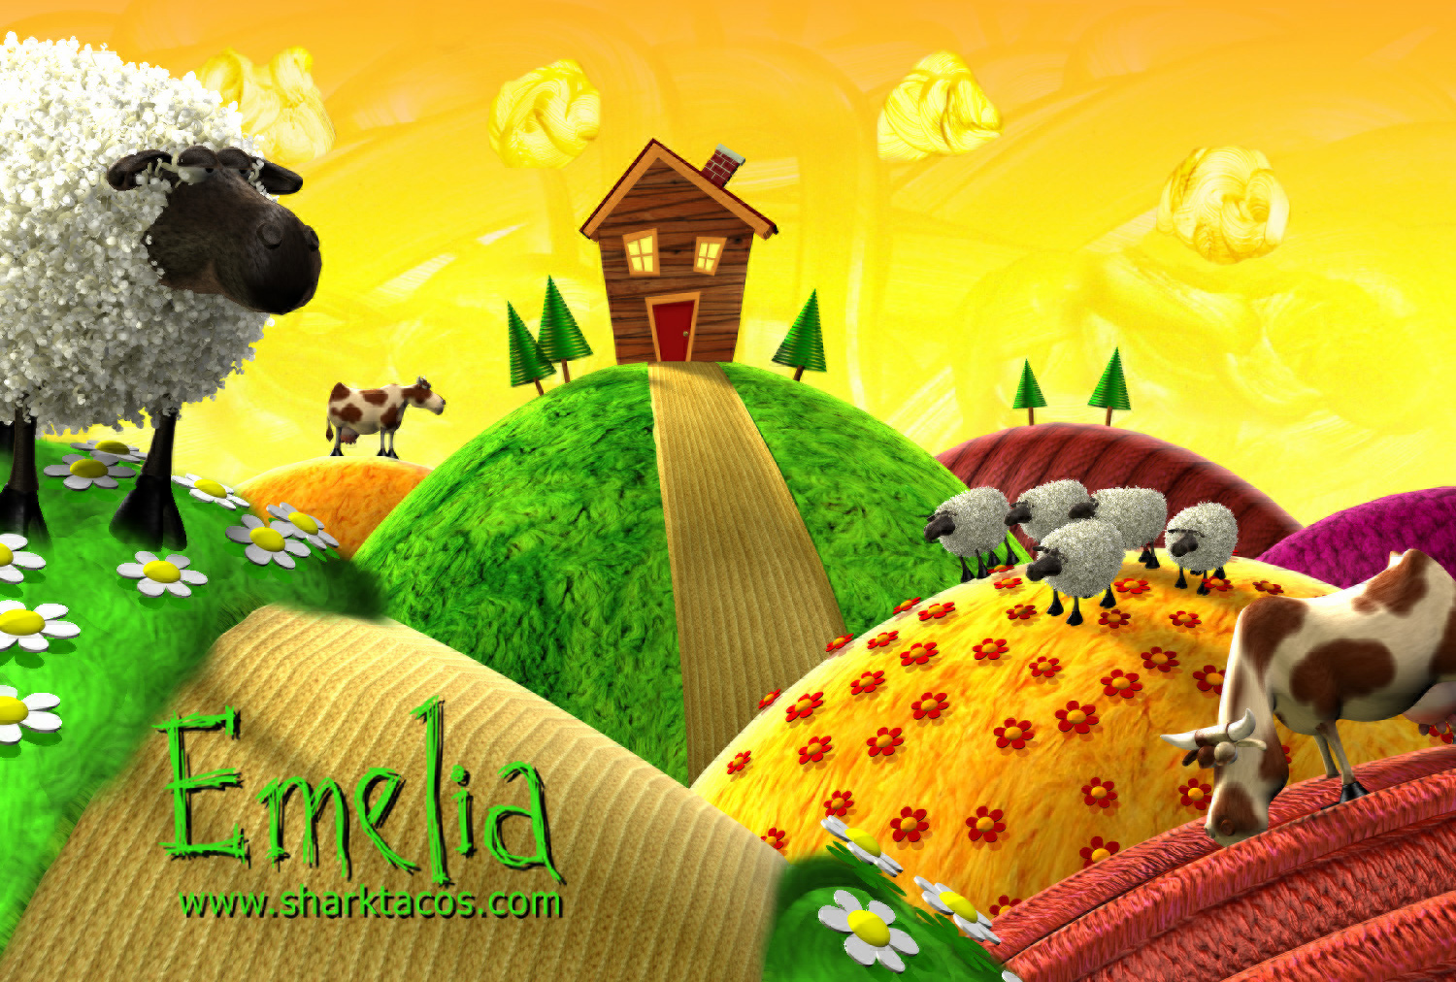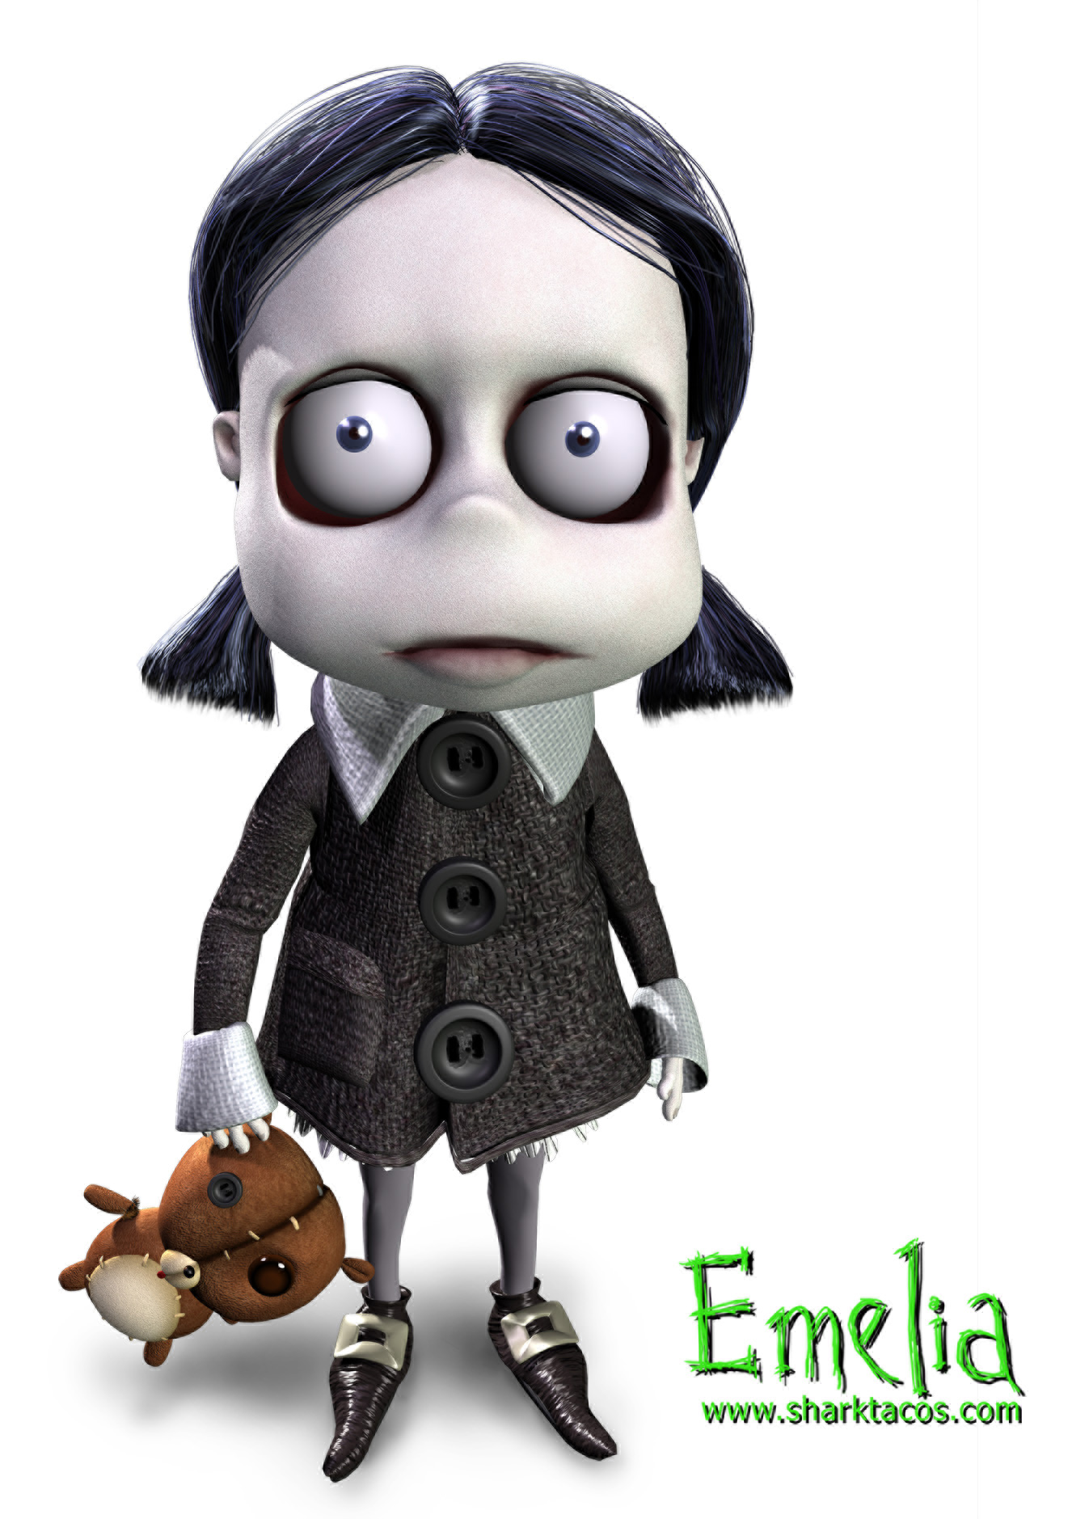
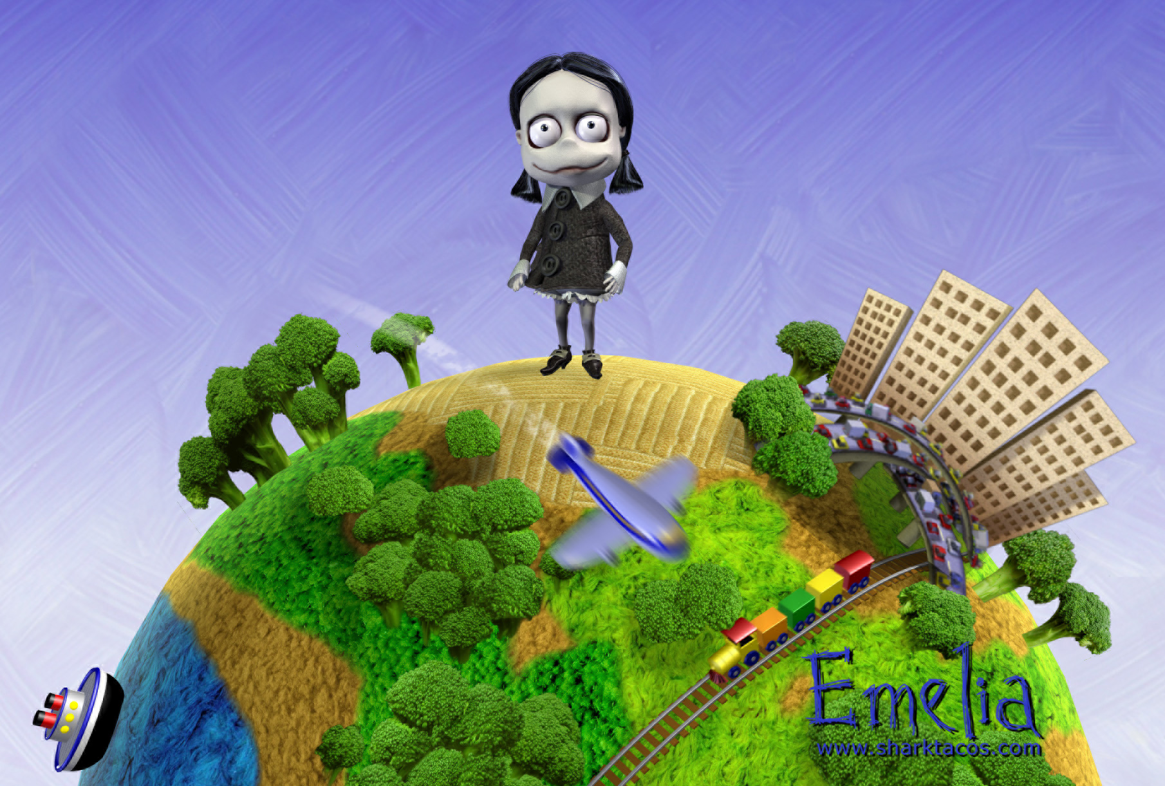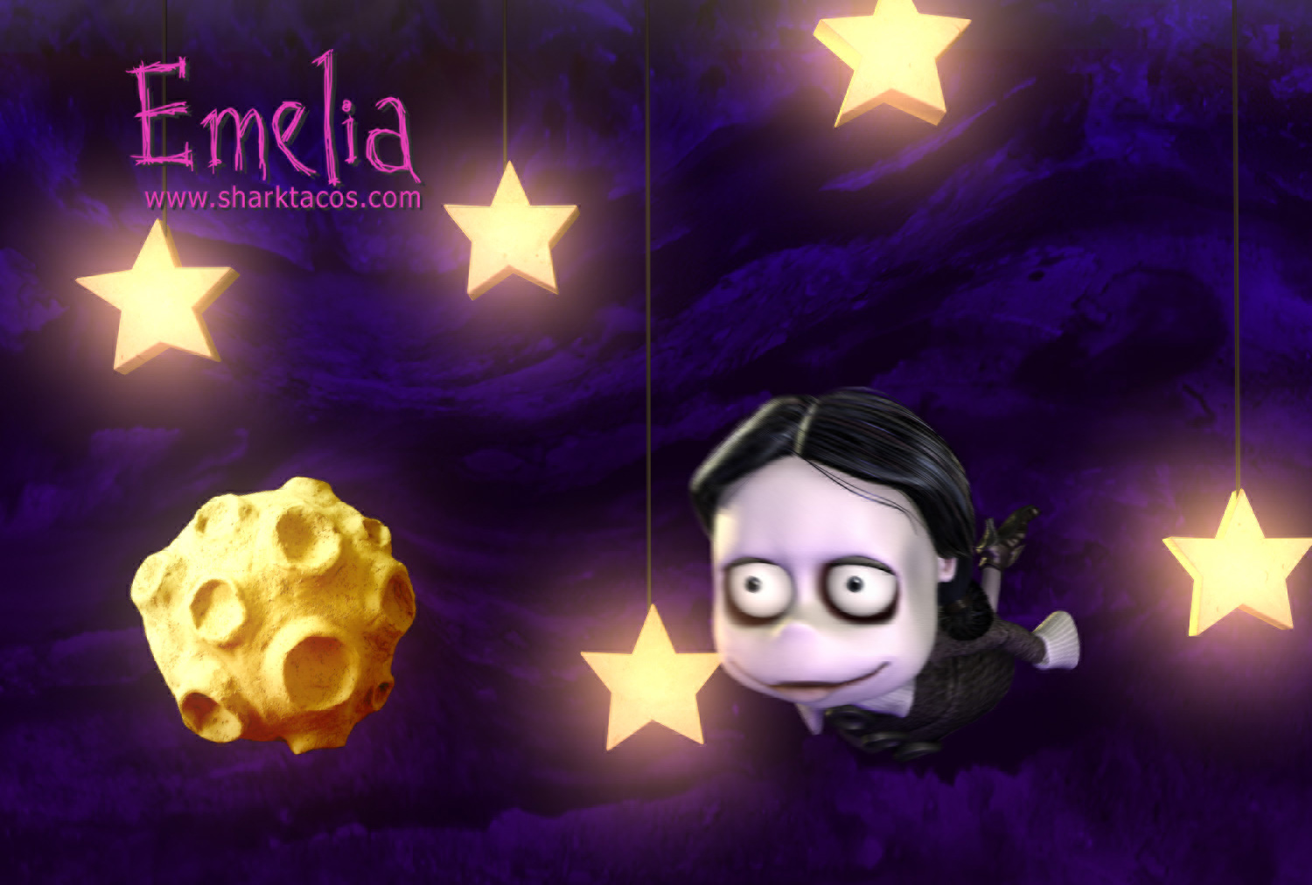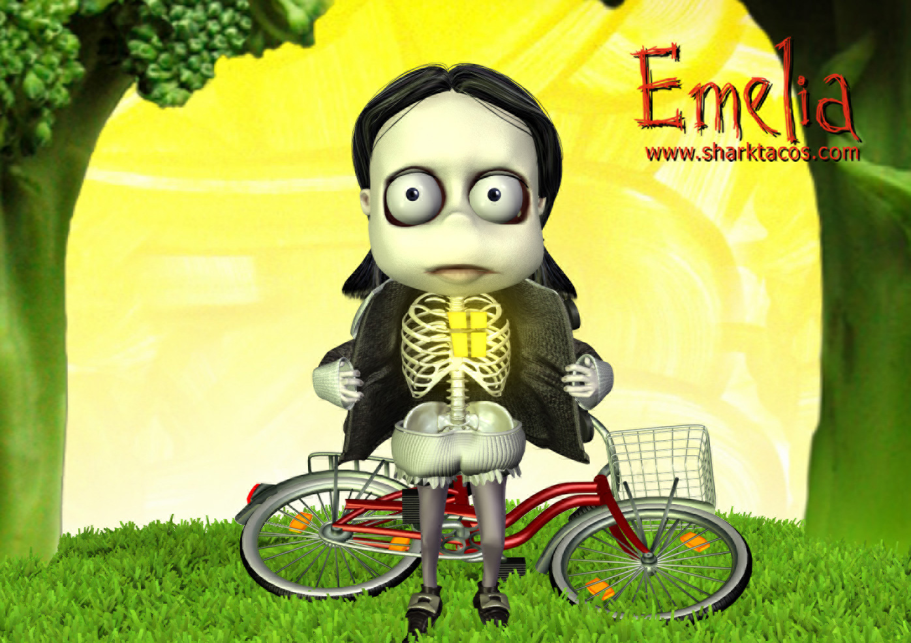

Film Description
9 minutes, Computer Animation
"Emelia" tells the story of a five-year-old goth girl and the world as seen through her eyes. This dark and quirky story of redemption takes us into Emelia’s head, letting us see in wild and fantastic images what Emelia feels and thinks internally as she confronts parents, playgrounds, and all the angst and despair that every little five-year-old goth girl has to deal with. And along the way, in seeing Emelia's insides, we just might see some of what's in our insides, too.

Awards and Screenings



Director Biography
For over a decade Derek Flood has been working as an animation director and lead animator for both high-end commercials as well as for feature films such as Roman Polanski's Oscar winning "The Pianist" as well as PDI/Dreamworks box office smash "Shrek 2". Additionally, Derek's independent short films have won awards and been chosen for the official selections at the most prominent animation festivals worldwide.
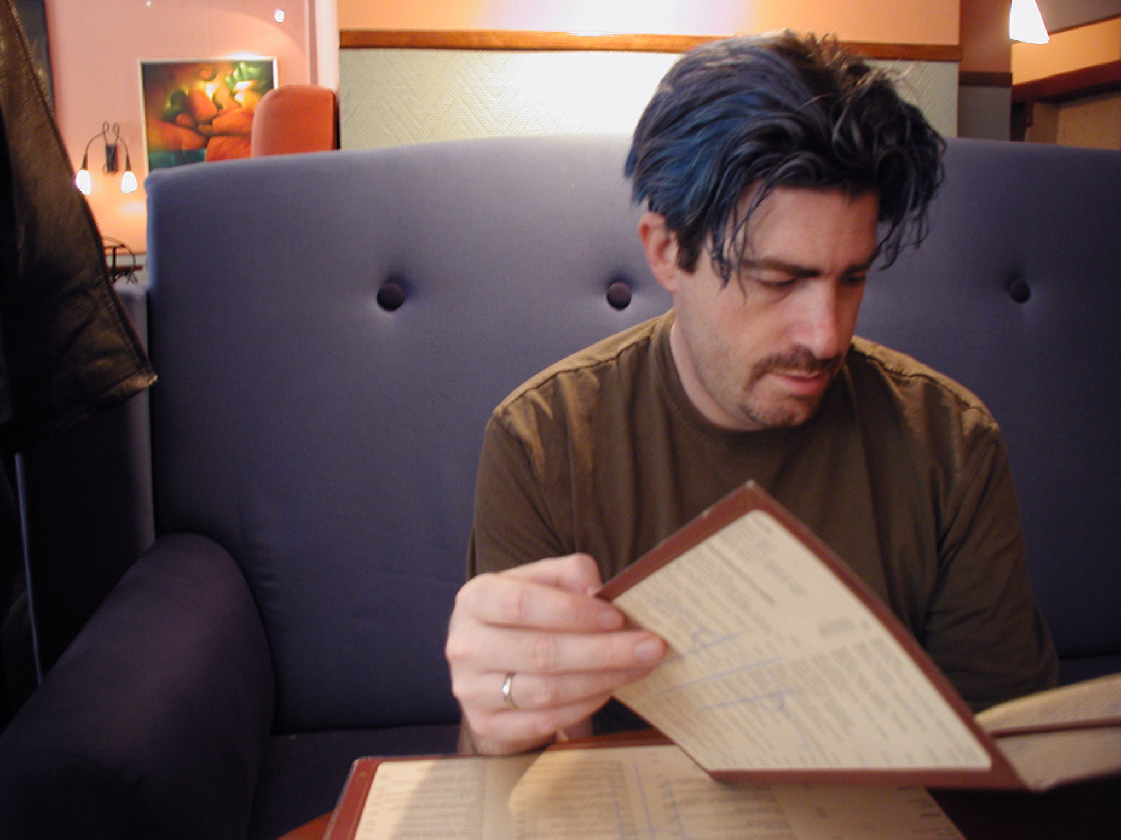
Director's Photo (2048x1536 JPG)

Copyright (c) 2005, All Rights Reserved.
All images and content including the Emelia character are international copyright (c) of Derek Flood and Sharktacos Studios
The Emelia character and logo are Trademarks (TM) of Derek Flood and Sharktacos Studio

